**Online Tools for Competitive Analysis Test Lab – CATWeb**

|  |  |  |  |  |
| --- | --- | --- | --- | --- |
| Product Design PRXXXXXX  Author: Juan Carlos Nieves  HP Confidential Revision and approvers  |  |  | | --- | --- | | **Inspectors** | * Rufino Real * Agustin Cristerna * Ivonne Pompa * Rocio Vallejo * Günter Hagedorn | | **Peer review type requested** | Circulation | |

# 

# Business Requirement resolved with this design

*Enumerate the business needs that will be covered by this design using free text.*

|  |  |
| --- | --- |
| **Business need** | **Description** |
| Fasten the process of scribes on getting a Master document for the authors after peer review meeting. | Multiple document inspection logs are the result of various inspectors. Scribe needs to consolidate them in one single document (the master) and add also the findings on the peer review meeting itself, making this step tedious and time consuming. |
|  |  |

# 

# Assumptions

*Assumptions are potential failure points in a project. They need to be monitored and managed. At the start of the project they should be noted, and used as input for the risk assessment. If new assumptions evolve, they should be treated in the same manner. The priority of the Assumption and the priority of the risk should be the same.*

|  |  |  |
| --- | --- | --- |
| **Assumption** | **Priority** (High, Medium, Low) | **Risk** (High, Medium, Low) |
| The new application will use SQL Server and C# | High | Low |
|  |  |  |
|  |  |  |

# Requirements matrix

*Enter the IDs and descriptions of other requirements that this document depends on.*

|  |  |  |
| --- | --- | --- |
| **BR ID** | **PR ID** | **PR’s Description** |
|  |  |  |
|  |  |  |
|  |  |  |

# Detailed product requirement

Detailed Functionality Description

*The new application will handle the process of documenting findings of a peer review.*

*The author will create a peer review in the application and inspectors will automatically be assigned as reviewers and one click access to enter their findings.*

*Application will have the following structure:*

*Users*

*Projects*

*Releases*

*Phases*

*Work items.*

*Users are assigned to projects.*

*Projects have releases and each release is divided into phases, which in turn have work items that the inspectors review.*

*These are the user roles:*

|  |  |  |  |  |  |  |  |  |
| --- | --- | --- | --- | --- | --- | --- | --- | --- |
|  | *Manage projects* | *Manage project users* | *Manage releases* | *Manage project phases* | *Manage work items* | *Manage inspection logs* | *Manage master logs* | *View others activity* |
| *Super user* | *x* | *X* | *x* | *x* | *x* |  |  | *X* |
| *Project admin* |  | *x* | *x* | *x* | *x* |  |  | *X* |
| *Member* |  |  |  |  | *x* |  |  | *X* |
| *Author* |  |  |  |  |  |  |  | *X* |
| *Inspector* |  |  |  |  |  | *x* |  | *X* |
| *Scribe* |  |  |  |  |  |  | *x* | *X* |
| *Viewer* |  |  |  |  |  |  |  | *x* |

*Roles responsibilities*

|  |  |
| --- | --- |
| *Permission* | *Actions allowed* |
| *Manage projects* | *Can add, edit, delete projects in the Peer Review tool space. This permission should be limited to a reduced number of people.* |
| *Manage project users* | *Can add or remove people from projects.* |
| *Manage releases* | *Can add, edit or delete releases within projects, so the peer reviews are organized between software versions.* |
| *Manage project phases* | *Every deliverable on a software life cycle belongs to a phase. And each phase have work items that need to be reviewed. This permission allows to create, add and delete project phases within a release.* |
| *Manage work items* | *Can create, edit and delete work items. Work items are just a representation of a document or deliverable, not the work item itself.* |
| *Manage inspection logs* | *Can create, edit and delete inspection logs. Inspection logs are the result of an inspection and contain all the findings of one inspector in particular.* |
| *Manage master logs* | *Can generate a master log from all the inspection logs or a set of selected inspections of a particular work item. Can also edit it for adding manually more findings.* |

UI Prototypes

*This section graphically describes how the intended section of the application will look like. Prototyping gives an overall idea of how the final product will look and behave in terms of graphical user interface.*

***Prototype 1:***

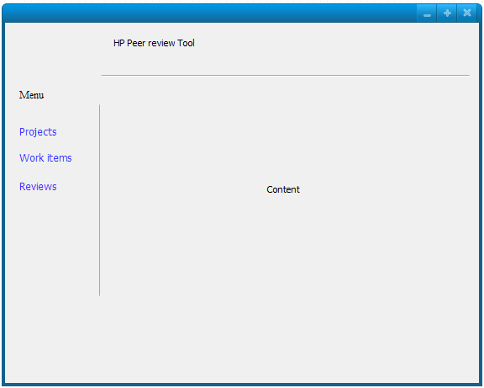

General look of the master page. At the left a navigation area controls the app sections. At the top a title and some HP logo.

***Prototype 2:***

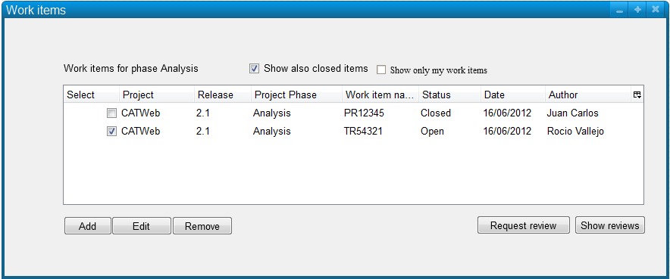

Work items page. Authors can manage work items and request a new review for them. Also can view the reviews of the work items. A work item can have multiple reviews.

***Prototype 3:***

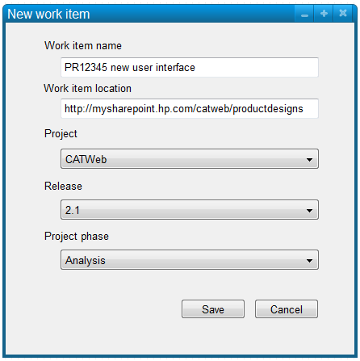

Add work item page. A work item consists of a name and a location (where inspectors should read it from). A work item belongs to a specific project phase within a release of a project.

***Prototype 4:***

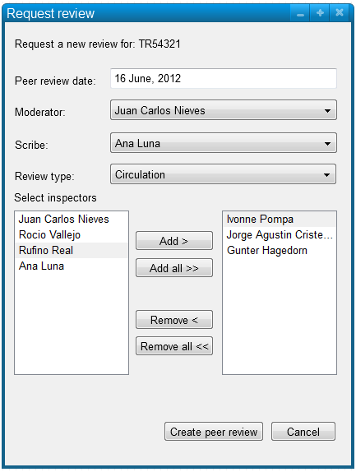

Request review page. On this page the author is calling for a review of their work item. A moderator and scribe are selected to play this role, along with the inspectors the author wants for this particular review. The review type field is a selectable drop down list with the following items: Buddy, Circulation, Inspection, and Walkthrough. After clicking “Create peer review” the system creates the entry on the system and sends an email to the selected people (moderator, scribe and inspectors) that they have been selected to participate on the peer review, showing the work item name, the location of the work item and a link to the peer review tool where they can enter their findings.

***Prototype 5:***

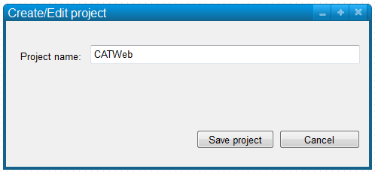

Create project page. At the moment just the name of the project is relevant. More data can be added later for PM purposes, like PPM ID or some sort of useful info. This same page is used while editing the project info.

***Prototype 6:***

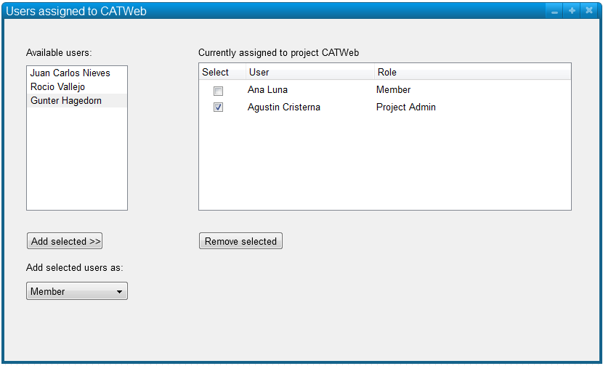

Manage project people page. From the already created users (all from the users table, created from the User Management module) the list from the left is populated and available to select to add to the project (grid at the right). When selecting people to add, a role can be selected as well, that can be Member or Project Admin. The remove button removes the people assigned to that project (but not the work items or reviews already done in that project, just the relationship of the person and the project). You get to this page from the Projects page, clicking on Assigned People

***Prototype 7:***

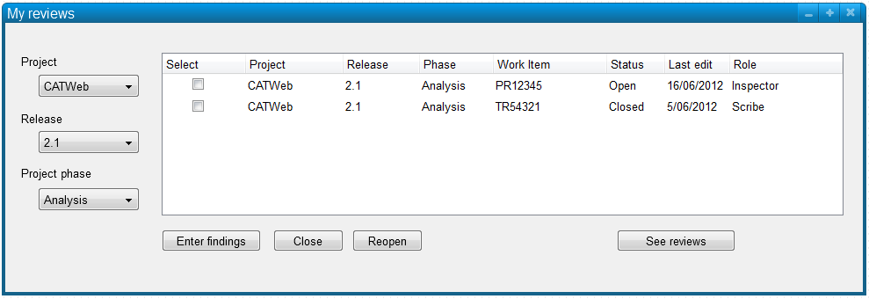

My reviews page. This page shows the reviews the current user has worked on. Upon peer review creation, reviews are automatically created for the inspectors selected. The inspectors need to enter this page and click on “Enter findings” to document the errors they encounter, make questions or suggestions. After completing entering findings, inspectors click on Close to mark the review as complete (and tell the moderator and scribe that specific review can be worked on). The “See reviews” button opens the “Review work item” page, in order to see all inspectors reviews and create a master review out of them. This button is only available if the permission “Manage master log” is enabled for the current role.

***Prototype 8:***

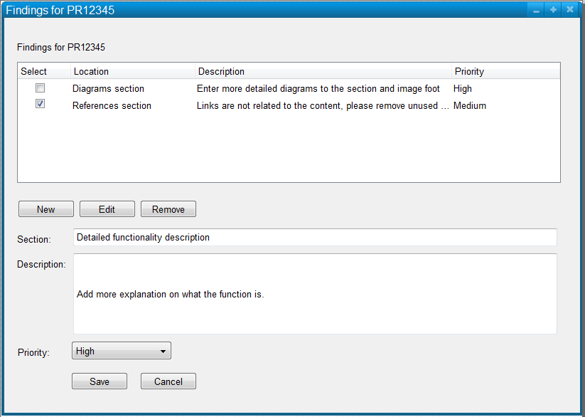

Enter findings page. This list manages the findings of the Inspector. Existing findings can be edited, making the lower controls active with that findings info. After clicking “Save” the selected finding is saved and grid refreshed. Same happens when “New” button is clicked. Lower controls get enabled to enter the new finding and after clicking “Save” the new entry is added to the grid and the grid gets refreshed after that. The cancel button is used only to cancel editing or creating a new finding.

***Prototype 9:***

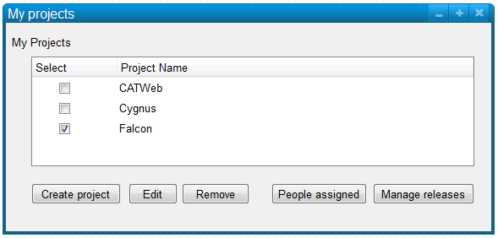

My projects page. All roles have access to this page. Depending on the roles permissions the buttons get enabled (refer to permissions table).

***Prototype 10:***

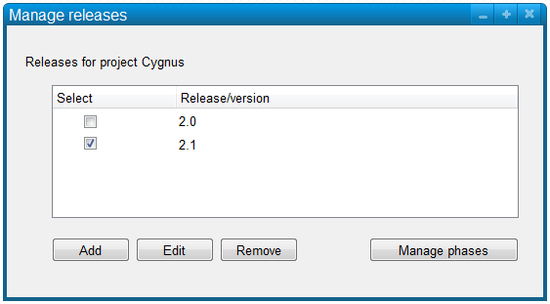

Manage releases page. This page is triggered from the “My projects” page for a given project. A number or a release name can be used for the release/version text. In this same page can open a “Manage phases” page in order to enter phases info. Removing a release should work only for releases without phases. Only a Super User can remove a release that has phases, but this also removes all work items and reviews for that release, that is why only Super Users should have this ability.

***Prototype 11:***

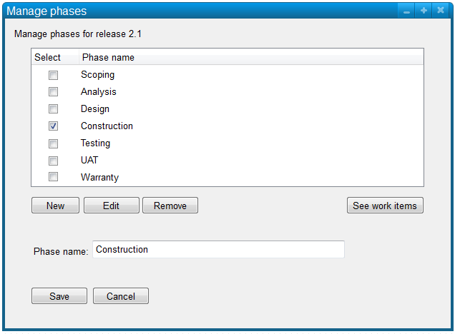

Manage phases page. Name should be relevant at the moment and same behavior should follow for the save, new and cancel buttons. “See work items” button opens the “Work items” page for that specific phase.

***Prototype 12:***

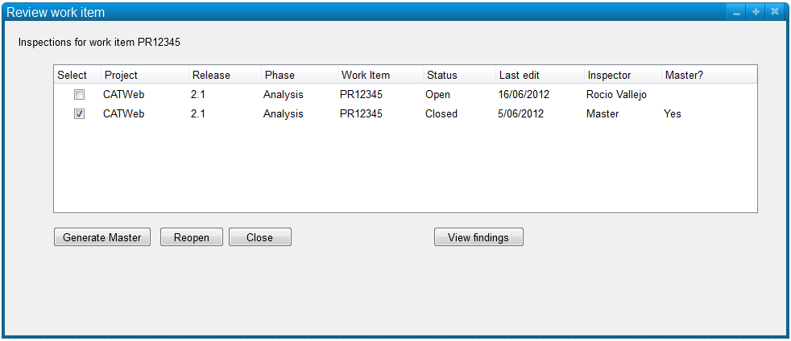

Review work item page. This page shows all reviews from a specific work item. Scribe uses this page to generate a Master review from the selected reviews and continue entering findings on the master during the actual peer review. This page is accessible from the “My reviews” page if the role has the “Manage master logs” permission (see permissions table). “Reopen” button opens again a revision for that inspector. “Close” button closes the revision for that inspector (forces) so a master document using that revision can be created. A master revision can be created using “Closed” revisions only. Open revisions indicate the inspector has not finished reviewing the work item. View findings button opens the “Findings” page. If the revision is not the master, read only controls are shown. Otherwise edition can be made to the master document. The normal flow should be: select the closed revisions to create a master from. Once created view the findings of the master and continue entering findings. Clicking on Generate Master again should remove ALL entries on the current master review and re-create it based on the selected closed revisions (Important on pre-entered data and a warning should be shown to the Scribe).

*Prototype 13:*

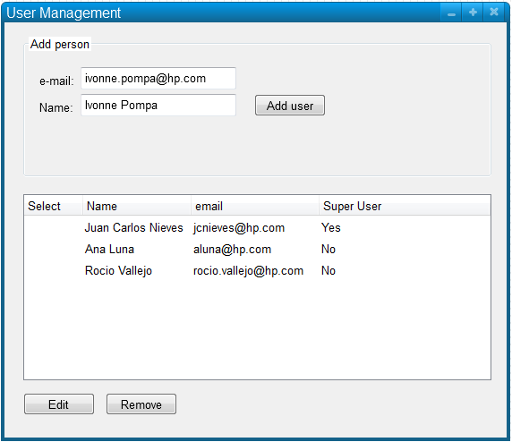

*User Management page. This page is available only to Super users. Users are added to the tool by super users. Project admins later add them to their specific projects and roles. Normally a Super Users only adds one person to a project (the project admin) and leave the task of assigning people to that project to the project admin with their specific roles.*

DB changes

*Describe in high level detail the database changes required to fulfill the business need. Be aware that any modification to the data definitions of tables or modifications to store procedures involves RFC special creation. The detailed changes specification will be documented on the technical design based on this PR.*

*New or modified tables*

|  |  |  |
| --- | --- | --- |
| **Table 1** |  |  |
| **Column** | **Description** | **Comments** |
|  |  |  |
|  |  |  |
|  |  |  |
|  |  |  |
|  |  |  |
|  |  |  |

*New or modified stored procedures*

|  |  |
| --- | --- |
| **Store procedure name** | **Description of the change** |
|  |  |
|  |  |
|  |  |

*New or modified functions*

|  |  |
| --- | --- |
| **Function name** | **Description of the change** |
|  |  |
|  |  |
|  |  |

Diagrams

***Important****: For standard in HP modeling use Microsoft Visio to create your diagrams.*

***Behavior diagrams section***

**Activity diagramS**

*Describes the business and operational step-by-step workflows of components in a system. An activity diagram shows the overall flow of control.*

**State diagram**

*Describes the states and state transitions of the system.*

**Use case diagram**

*Describes the functionality provided by a system in terms of actors, their goals represented as use cases, and any dependencies among those use cases.*



Actions a super users is allowed to perform.

***Interaction diagrams section***

**Sequence diagram**

*Shows how objects communicate with each other in terms of a sequence of messages. Also indicates the lifespans of objects relative to those messages.*

# Acronyms

*Explain the acronyms used during this technical design.*

|  |  |
| --- | --- |
| **Acronym** | **Meaning** |
|  |  |
|  |  |
|  |  |
|  |  |
|  |  |
|  |  |
|  |  |
|  |  |

# 

# Testing strategy

*Describe how the functionality covered by this design should be tested.*

*If a manual test will be used,* ***describe the steps****.*

*If automated test will be used, then* ***list the name of the automated tests*** *used.*

|  |  |
| --- | --- |
| **<Manual test 1>** |  |
| **Step action** | **Expected result** |
|  |  |
|  |  |
|  |  |

|  |  |
| --- | --- |
| **<Automated Test 1>** |  |
| **Functionality being tested** | **Automated test created or modified** |
|  |  |
|  |  |
|  |  |

# References

Pencil Project Prototyping tool: <http://pencil.evolus.vn/en-US/Home.aspx>

Unified Modeling Language: <http://www.uml.org/>

Understanding Project Assumptions: <http://www.projectperfect.com.au/info_assumptions.php>